# Problem Statement:

1. Create Service module for integrating Attendance System with database using Web API and dynamically fetching data on request.
2. Allowing employees to report issue on attendance record of any day.

# Requirements:

## Web API Module:

1. Develop Web API with MVC Architecture containing following controller
   1. PastMonthAttendanceRequest
      1. This model should connect database and fetch in-time and out-time for current month and previous month data for logged in User
      2. Data should be returned in JSON format from the service
      3. Note: You are free to choose logic to identify current month and previous month
2. Log exceptions in event viewer when there is any unhandled exception generated in service
3. Show loading image in popup before sending AJAX request to fetch data from WebAPI
4. Loading image should be hidden when data is successfully or if there is error fetching data from WebAPI
5. In case of error Popup should display below message in in Calendar popup instead of Calendar control.

Message:

|  |
| --- |
| :(  Sorry, an error has occurred while retrieving your attendance. Please try refreshing the browser or contact IT Help Desk for assistance. |

1. On Successful data load calendar should display In-time and out-time for user with format mentioned in Frontend requirement module. (I.e. Color of Text and alignment for text on each date)

## Report an Issue Module

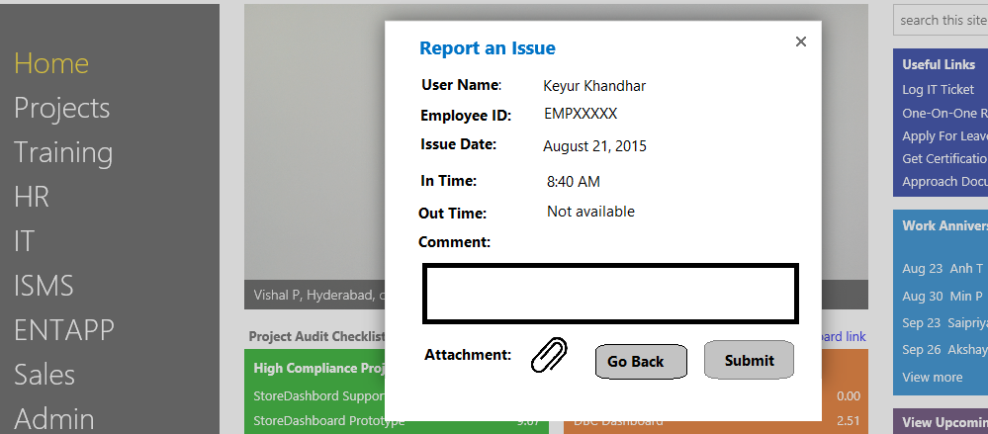

1. When user clicks on Submit, data should be pushed into a SharePoint list
2. Expected Schema of SharePoint list
   1. UserName – Single Line of Text
   2. EmployeeID – Single Line of Text
   3. Issue Date – Date
   4. In-Time – Single Line of Text
   5. Out-Time – Single Line of Text
   6. Comments – Multiple line of Text
3. Values should be pushed to SharePoint using SharePoint REST APIs
4. **Note:** Adding attachment field is optional in SharePoint list, adding this functionality will be value add in current application.

# Week Wise Expectation:

## Week 1:

1. Develop WebAPI with required controller using MVC architecture
2. Connect WebAPI to database and fetch current month and previous month attendance for logged in user
3. Add Exception logging in event viewer for all unhandled type of exception

## Week 2:

1. Bind data fetch from WebAPI on calendar popup and apply formatting on dynamic data
2. Add scenarios for error handling

## Week 3:

1. Create SharePoint Tenant for creating SharePoint List and adding issues sent for user from popup
2. Create SharePoint list with expected schema
3. Create JavaScript module for inserting data to SharePoint list

## Week 4:

1. Integration of all components
2. Cover up for pending Items if any.

# Reference/Study Material:

1. <http://www.asp.net/web-api/overview/getting-started-with-aspnet-web-api/tutorial-your-first-web-api>
2. <https://msdn.microsoft.com/en-us/library/xzwc042w(v=vs.110).aspx>
3. <https://msdn.microsoft.com/en-us/library/office/jj164022.aspx>
4. <http://www.codeproject.com/Articles/990131/CRUD-Operation-to-List-Using-SharePoint-Rest-API>